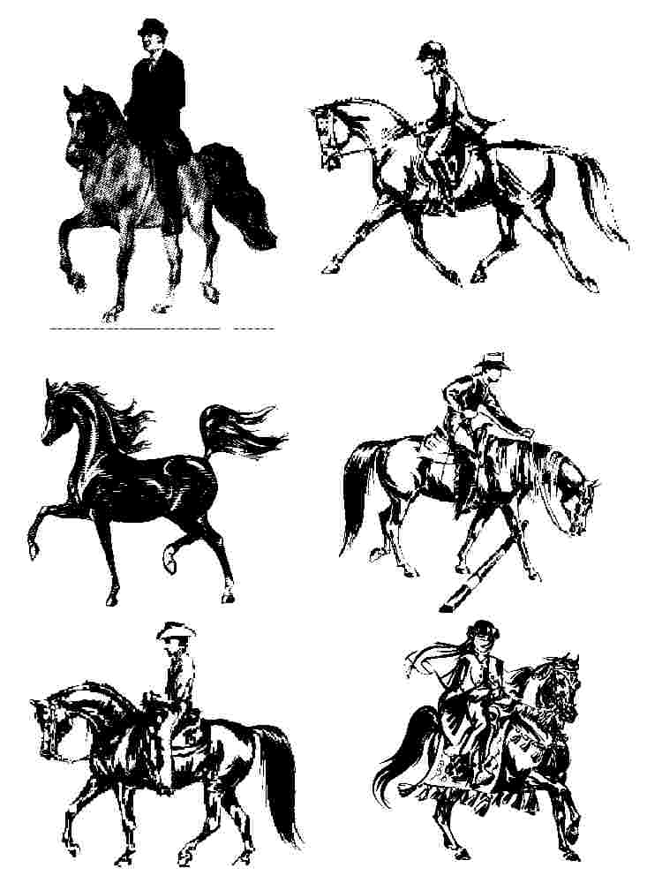
Arabian autumn Classic Horse Show 2023
T-Shirt form
September 15 – 17, 2023
Bryan, TX

Gulf coast autumn Egyptian classic
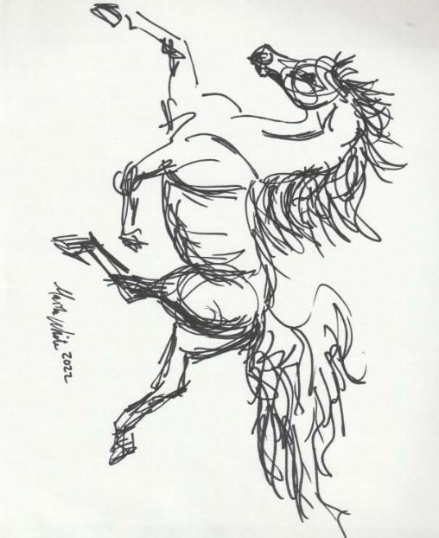
t-shirt front

Back of t-shirt – will have Egyptian sponsors names

Each entry (horse) in the Egyptian classes is eligible for a FREE t-shirt. If you plan to enter and would like a FREE t-shirt, please notify Martha White via email: morabene@yahoo.com by September 1, 2023. You will need to provide:

Your name: Size:

Cell Phone#

Your Egyptian or Heritage Egyptian horse’s name:

Available Youth Sizes: Small, Medium and Large
Available Adult Sizes: Small, Medium, Large, X-Large and 2XL

Purchase of t-shirts available: To help us ensure we have your size and enough t-shirts, please place a preorder. If you are NOT showing in an Egyptian class but would like a t-shirt or simply want extra t-shirts, you can preorder at a cost of $15 or $20 each and pay for it at the show. Cost depends on the quantity club orders. Please submit your t-shirt request to Martha White. You will nee to provide: 1) Your Name, 2) Barn Associate with, 3) Size, 4) Quantity, and 5) Cell Phone #.

REMEMBER TO SUBMIT YOUR REQUEST BY SEPTEMBER 1, 2023, to Martha White, morabene@yahoo.com

